21 Editors - Properties Editor - Scene Tab
Scene Tab 3
Scene Panel 3
Camera 3
Background Scene 3
Active Movie Clip 3
Units Panel 3
Unit System 4
Unit Scale 4
Separate Units 4
Rotation 4
Length 4
Mass 4
Time 4
Gravity Panel 4
Enable 5
Gravity X, Y Z 5
Animate Property 5
Keying Sets Panel 5
Keying Set List 5
Add / Remove Keying Set 5
Description 5
Export to file 6
Active Keying Set 6
Paths 6
Add / Remove Paths 6
Target ID Block 6
Data Path 6
Array all Items 6
FCurve Grouping 7
Keyframe Settings 7
Only Needed 7
Visual Keying 7
XYZ=RGB Colors 7
Audio Panel 7
Volume 7
Distance Model 7
Audio Channels 8
Sample Rate 8
Doppler Speed 8
Doppler Factor 8
Update Animation Cache 8
Rigid Body World Panel 8
Activate 8
Settings 9
Collection 9
Constraints 9
Speed 9
Split Impulse 9
Steps Per Second 9
Solver Iterations 9
Animate Property 9
Cache 9
Simulation Start / End 9
Bake 9
Calculate to Frame 9
Current Cache to Bake 10
Bake All Dynamics 10
Free All Bakes 10
Update All To Frame 10
Field Weights 10
Custom Properties Panel 10
Add 11
Edit 11
Remove 11

Scene Tab
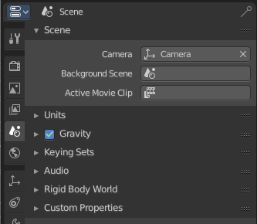
The Scene tab contains settings around the current scene.
Blender just allows to load one scene file at a time. But you can create more scenes in one blend file. And you can append scenes.

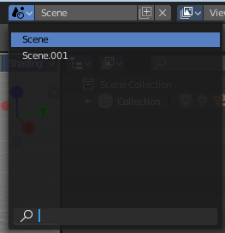
The scenes can be managed in the scene dropdown box up right in the header.
Appending happens through the File menu / Append

Scene Panel

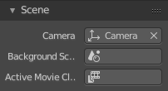
Camera
Here you can define the active camera for rendering.

Background Scene
Here you can choose a background scene.

Active Movie Clip
Here you can choose an active movie clip for constrainst and viewport drawing.

Units Panel

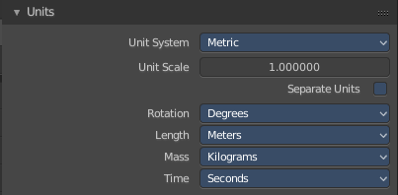
Here you define the units for the scene.

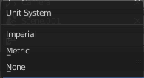

Unit System
The overall unit system that gets used.

Unit Scale
The standard unit scale

Separate Units
Display Units in pairs.

Rotation
Units to display on rotation. Radians or Degree.

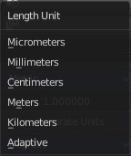
Length
Units to display the length values.

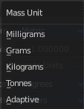
Mass
Units to display the mass values.

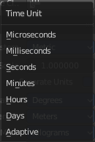
Time
Units to display Time values.

Gravity Panel

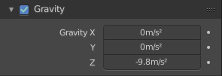
Here you can adjust the gravity settings. The default values are the standard gravity than on earth with the usual acceleration of 9.81 meters per second in Z direction.

Gravity is used for physics simulations like rigid body.

Enable
In the header is a checkbox to enable the gravity.

Gravity X, Y Z
The gravity values.

Animate Property
These properties can be animated. Activating this button sets a keyframe.

Keying Sets Panel
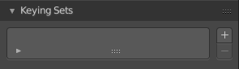

Keying Sets are a collection of properties. They are used to keyframe multiple properties at the same time.
There are some built in Keying Sets, and also custom Keying Sets called Absolute Keying Sets.
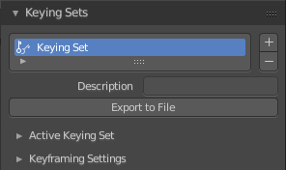
This panel here is used to add, select and manage Absolute Keying sets.
When you add a custom keying set in the list box, then you will reveal further options.

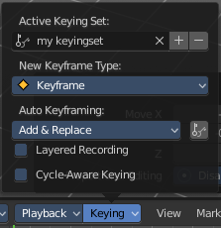
Every keying set that you add here is also available in the list of active keyingsets.

Keying Set List
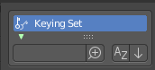
Here you can see the list of your Absolute Keying Sets. The active keying set is highlighted in blue.
It has a search form below the list. Click the arrow button down left to expand the search.
The list display can be resized by clicking at the dotted area and drag it up or down.

Add / Remove Keying Set
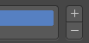
At the right side you can add or remove a keying set with the + and - buttons

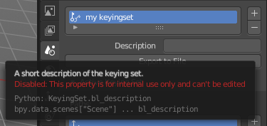
Description
A useless field where you could add and read a description when there would be a way to add one ....

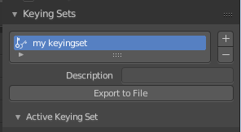
Export to file
Here you can export the keyingset to a Python file.
To re add the keying set from the File.py, open then run the File.py from the Text Editor.

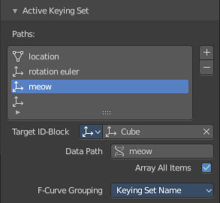
Active Keying Set
Here you can add properties to the active keying set.

Paths
A list with a collection of Paths each with a Data Path to a property to add to the active Keying Set. The active Path is highlighted in blue.
It has a search form below the list. Click the arrow button down left to expand the search.
The list display can be resized by clicking at the dotted area and drag it up or down.

Add / Remove Paths
At the right side you can add or remove a keying set with the + and - buttons


Target ID Block
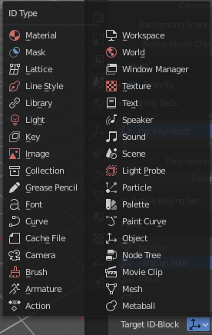
Set the ID-Type + Object ID Data Path for the property. Means pick the object or data type that you want to influence here.

At the left you have a list of the available ID Types. At the right you have a picker as long as you haven't defined the object where you want to use this prpoerty at. Use this picker to pick up the object.

Data Path
Here you can give your paths a name.

Array all Items
For an Array / Vector type, use All Items from the Data Path or select the array index for a specific property.

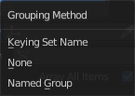
FCurve Grouping
This controls what Group to add the Channels to. Keying Set Name, None, Named Group.

Keyframe Settings
General Override and Active Set Override have the same items each.

Only Needed
Only insert keyframes where they’re needed in the relevant F-Curves.

Visual Keying
Insert keyframes based on the visual transformation.

XYZ=RGB Colors
For new F-Curves, set the colors to RGB for the property set, Location XYZ for example.

Audio Panel
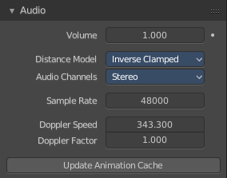
Here you can adjust the general audio settings.

Volume
The Audio Volume.

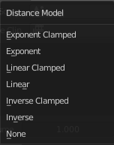
Distance Model
The algorithm for attenuation calculation.

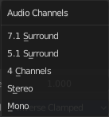
Audio Channels
Audio Channels settings.

Sample Rate
The sample rate for audio playback.

Doppler Speed
Speed of sound for doppler effect calculation.

Doppler Factor
Pitch factor for doppler effect calculation.

Update Animation Cache
Update the audio animation cache. Something that you might want to do after changes here ...

Rigid Body World Panel

The rigid body world is a group of Rigid Body objects, which holds settings that apply to all rigid bodies in this simulation.
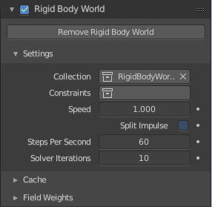
When you add Rigid Body physics on an object, primary there is created a group of objects with default “RigidBodyWorld” name. Rigid body objects automatically are added to this group when you add Rigid Body physics for them.
You can create several Rigid Body World groups, and allocate the Rigid Body objects with Groups panel in Object context.
Rigid body objects and constraints are only taken into account by the simulation if they are in the groups specified in Group field of the Rigid Body World panel in the Scene context.

Activate
In the header is a checkbox where you can enable or disable the Rigid Body World.
Remove Rigid Body World
Remove Rigid Body simulation from the current scene.

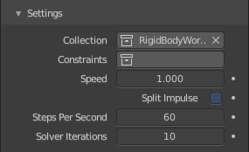
Settings
A sub menu with further settings.

Collection
Containing rigid body objects participating in this simulation.

Constraints
Containing rigid body object constraints participating in the simulation.

Speed
Can be used to speed up/slow down the simulation.

Split Impulse
Enable/disable reducing extra velocity that can build up when objects collide (lowers simulation stability a little so use only when necessary). Limits the force with which objects are separated on collision, generally produces nicer results, but makes the simulation less stable (especially when stacking many objects).

Steps Per Second
Number of simulation steps made per second (higher values are more accurate but slower). This only influences the accuracy and not the speed of the simulation.

Solver Iterations
Amount of constraint solver iterations made per simulation step (higher values are more accurate but slower). Increasing this makes constraints and object stacking more stable.

Animate Property
These properties can be animated. Activating this buttons sets a keyframe.

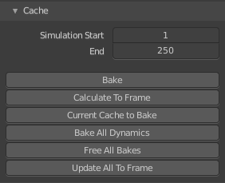
Cache
A submenu with chache settings. The cache is getting used for animation.

Simulation Start / End
First and last frame of the simulation.

Bake
Calculates the simulation and protects the cache. You need to be in Object mode to bake.

Calculate to Frame
Bake physics to current frame.

Current Cache to Bake
Bake from Cache.

Bake All Dynamics
Bake all physics.

Free All Bakes
Free all baked caches of all objects in the current scene.

Update All To Frame
Update cache to current frame.
If you haven’t saved the blend file, the cache is created in memory, so save your file first or the cache may be lost.

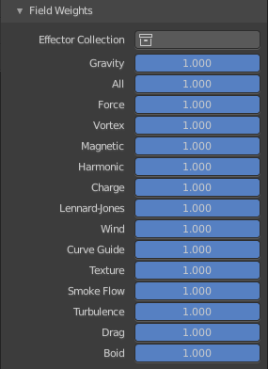
Field Weights
With force fields you can influence rigid body objects in physics simulations. Every force field has its own local settings, which can be adjusted in the physics panel. Here you can adjust the general field weights for those forces.

Custom Properties Panel


Here you can define custom properties that can be used for scripting.

Here you might also find custom properties from addons or scripts. User Prefs Props are listed here for example.
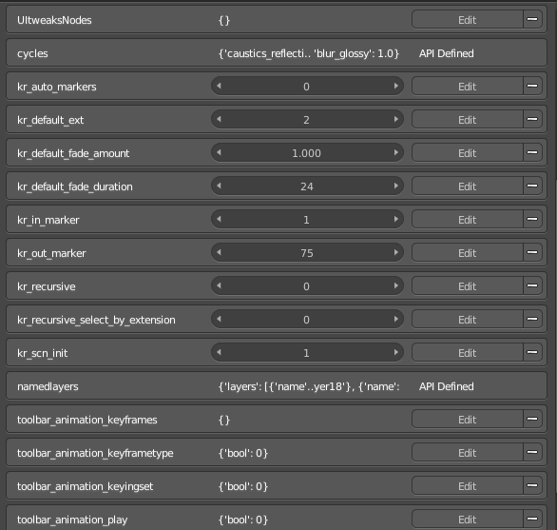

Add
Adds a new property.


Edit
A panel where you can adjust the settings for the custom property.

Remove
Removes the property.

